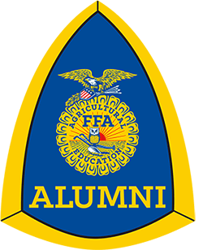
2024 Clinton FFA Alumni
Scholarship Eligibility

- Must be a student of Clinton High School or a college/university, and a current or past member of the Clinton FFA Chapter.

- Multiple scholarships may be awarded for qualified applicants.

- Previous recipient(s) of the scholarship, who are currently enrolled in college, are eligible to reapply for the scholarship each year until completion of his or her associate’s or undergraduate degree.

- Must currently be enrolled in or plan to attend college in an agriculture, agriculture-related field, or field that provides a service to those involved in agriculture.

- Must complete the FFA Alumni Scholarship Application form and submit to the Clinton High School Office by Friday, April 5th, 2024.

- Must participate in an interview conducted by the Clinton FFA Alumni Scholarship Committee in official dress for FFA members and business casual for all others.

- Interviews will be conducted by the Alumni on Monday, April 8th, 2024.

- If an applicant is unable to attend in person, the Clinton FFA Alumni Committee will try to make other arrangements (video call or Zoom meeting).

- Applicants will be notified by the Committee of individual interview date & times.

- The Clinton FFA Alumni scholarship committee will make the final decision on the scholarship selection(s).

- If awarded a scholarship, applicant(s) must provide proof of enrollment in college or university prior to payment of scholarship.

- If awarded a scholarship, the recipient or family representative will be expected to participate in one fundraising event during the calendar year, such as Apple N Pork or Mum Fest.
Clinton FFA Alumni
Scholarship Application

Application Questions:
- Name:
- Address:
- Email:
- Telephone Number:
- Name of Parents or Guardian:
- College or University you plan to attend:
- Address of College or University:
- Area of study/major:
- When will you begin college (fall 2024, etc.):
- Class rank and/or grade point average:
- How many years have you been an FFA member?

- List the agriculture classes have you taken:

- List other related classes you have taken:

- List the FFA activities/events have you have participated in:

- Describe your Supervised Agriculture Experience (SAE) program while in FFA:

- List your FFA accomplishments and/or awards you received:

- List other school, college or community activities have you participated in, including any awards and honors you have received:

- Describe how being a member of FFA has benefited you the most:

- List any additional information you feel might be of value to your application:

